CONSTITUTION AND BY-LAWS

of the

ROCKY MOUNTAIN PETROLEUM ACCOUNTING SOCIETY
(RMPAS)



RMPAS FEDERAL TAX ID 87-0432789

CONSTITUTION AND BY-LAWS
of the
ROCKY MOUNTAIN PETROLEUM ACCOUNTING SOCIETY

ARTICLE I - NAME AND OBJECTIVE

Section 1 - The name of this Society shall be the Rocky Mountain Petroleum Accountants Society. (Society)

Section 2 - Objective. The objective of this Society shall be to unite and improve the effectiveness of all persons interested in petroleum and energy extractive industry accounting. To promote the development of improved accounting practices, methods and procedures; to advance the standing of the profession.

Section 3 - Affiliation. It is the intent of this Society to be affiliated with the Council of Petroleum Accountants Societies (COPAS).

Section 4 - Fiscal Year. The fiscal year shall begin on the first day of October and end on the 30th of September.

ARTICLE II – MEMBERSHIP

Section 1 - Eligibility. In order to be eligible as a member of this Society one must:

Section 1.1 - Be engaged in petroleum and related energy industry activities, public accounting or other fields of expertise directly connected with the petroleum industry, and

Section 1.2 - Be approved by the Membership Committee, reviewed by the
President and confirmed by the Executive Committee.

Section 2 - Limitations of Membership. The Board of Directors is hereby vested with the power to limit the maximum number of members.

Section 3 - Types of Memberships.

Section 3.1 - Regular Membership. In order to qualify for this type of membership, an individual must meet all the eligibility requirements as stated in Section 1 of this Article. Regular Members will be entitled to full voting privileges.

Section 3.2 - Honorary Members. The Board of Directors shall have the authority to bestow upon any speakers, past officer, member, or other dignitary an honorary membership, which will not carry the voting privilege nor be subject to payment of dues or guest fees.

Section 4 - Resignation and Expulsion.

Section 4.1 - In the event that any member wishes to resign, he will be free to do so; however, there shall be no refund of dues.

Section 4.2 - The nonpayment of dues within the prescribed time, as set out in Article IV, shall automatically forfeit the membership of any individual.

Section 4.3 - Any member adjudged by the Board of Directors to have violated the Constitution and By-Laws of the Society, or who by two-thirds (2/3) vote of the Board of Directors be found guilty of conduct rendering him unfit to continue membership, shall be expelled. Any member so expelled shall have refunded to him the unexpired portion of his dues which have been paid.

ARTICLE III – VISITORS

Section 1 - Any member shall be entitled to have guests at Society sponsored functions, providing that the Society will establish a rate to be charged to such guests. The Board of Directors is vested with the powers to limit guests as the need arises due to space limitation and in order to first accommodate the membership. Guest fees shall be paid in advance at the time the member makes the guest reservation.

Section 2 - The Society shall pay the meal expense of all principal speakers. In the event that out-of-town speakers are invited to participate, the Society may reimburse such speakers for all expenses connected directly with the speaking assignment.

ARTICLE IV - FINANCES

Section 1 - Dues. Dues of Regular Members shall be the amount per year approved by the Board of Directors each year, payable when billed. There shall be a proration of dues. Any member joining during the fiscal year shall pay a prorated amount of dues in accordance with a fee schedule established by the Board of Directors. This fee structure is subject to revision as the Board deems necessary.

Section 2 - Non-Payment of Dues. The membership of any individual who fails to pay dues within sixty (60) days from the date dues are payable, may be terminated.

Section 3 - The Board of Directors may refuse to accept the dues of any member who is guilty of conduct described in Article 11, Section 4.3 and who is, therefore, subject to expulsion from the Society as provided in said Article and Section.

ARTICLE V - MEETINGS

Section 1 - Bi-monthly Meetings. Regular meetings of the Society shall normally be held bi-monthly, at a time and place designated by the Board of Directors. Such meetings shall be dinner/luncheon meetings. The Board of Directors by a two-thirds (2/3) majority vote may, at its discretion, have power to change or cancel the date of any meeting when, in its judgment, such change or cancellation will be for the best interest of the Society.

Section 2 - Special Meetings. A special meeting of the Society may be held at any time and place on call or notice by the Board of Directors which it may give on its own initiative and which it shall give upon the written request of ten (10) Regular Members. The call or notice shall be mailed to each member at least ten (10) days prior to the date set therein for the meeting and shall state the purpose thereof.

Section 3 - Annual Meeting. The annual meeting of the Society for the election of Directors and transaction of any other business related to its affairs, shall be held at a date as designated by the Board of Directors. The Nominating Committee shall nominate three (3) members for Board of Directors; and, any other member who has expressed willingness to serve may be nominated from the floor.

Section 4 - Meeting Notice. The Secretary shall make telephone contact or mail a notice of each meeting (annual or regular), stating the time and place of such meeting, to each member prior to the meeting date; but no failure or defect in notice of such meeting shall invalidate the same or any procedure taken thereat.

Section 5 - Order of Business. The order of business at all meetings of the Society, of the Board of Directors, of the Executive Committee, and of all the other committees, shall be such as may be prescribed by the presiding officer, and if objection be made thereto, then by a majority vote of the meeting. Robert's Rules of Order shall govern all meetings of the Society, of the Board of Directors, of the Executive Committee, and of all other committees, on any point not covered by the Constitution and By-Laws.

Section 6 - Voting-General. At each meeting of the Society, each member present, eligible to vote, shall be entitled to one vote. All actions brought before the membership shall be subject to a majority vote of members present, except the approval of two-thirds (2/3) of the members present are required for the matters set forth in Article VI, Section 10 and Article XIII, Section 2. There shall be no voting by proxy. Voting by mail may be authorized by the Board of Directors.

ARTICLE VI - BOARD OF DIRECTORS

Section 1 - Number of Directors. The Board of Directors of the Society shall consist of nine (9) Regular Members, who shall be elected by the Regular Members.

Section 2 - Terms of Office. The terms of office shall be as follows: three (3) Directors for a period of three years; three (3) Directors for a period of two years; and three ( 3 ) Directors for a period of one year. At each annual meeting thereafter there shall be elected by a majority vote of the Regular Members present and voting, three (3) Directors for a period of three years to replace retiring Directors. Each member is entitled to cast one vote per nominee.

Section 3 - Vacancies and Replacements. Directors shall hold office until their successors are elected and have qualified. If any director shall die, or his office otherwise becomes vacant, his unexpired term shall be filled by a majority vote of the members of the Board of Directors, then serving as such and present and voting. If, for any reason, the required number of Directors are not elected at the annual meeting, they may be elected at any special meeting called for this purpose by the Board of Directors. If membership in the Society of any Regular Member who has been elected a
Director for any reason terminates, his office as Director automatically becomes vacant.

Section 4 - Meetings and Quorum. The Board of Directors shall meet at least quarterly at such time and places as it may elect. At such meetings five (5) Directors present in person shall constitute a quorum. At all meetings of the Board of Directors, the President of the Society if present, shall act as Chairman. Notices of Directors' meetings shall be mailed by the Secretary, or as the Board may otherwise direct, but no defect in notice nor failure to give such notice shall invalidate the meeting or any proceedings taken thereat as long as a quorum is present.

Section 5 - Reelection of Directors. Directors shall be eligible to succeed themselves. A retiring Director who is also the retiring President shall remain an ex-officio member of the Board of Directors for a period of one (1) year, but shall not be a voting member.

Section 6 - Company Representation of Board. Not more than three (3) members of any Company shall be eligible to serve on the Board of Directors, as a voting member at one time. For the purpose of this section, all subsidiaries or affiliated companies in the same group shall be considered as one (1) Company and shall not be represented by more than three (3) members of the Board of Directors at one time.

Section 7 - Removal of Director. Any Director may by removed by a two-thirds (2/3) vote of the Board of Directors at a meeting called for that purpose, after such preceedings as the Board of Directors may determine. Upon such removal of a Director, his office shall be filled for the unexpired term thereof by a majority vote of the Board of Directors.

Section 8 - Duties and Responsibilities. The duties of the Board of Directors shall be to act on all proposals under the jurisdiction of the Board, and properly conduct the business of the Society. The Board shall have full power to rule on any business except those powers delegated to the Society as a whole, and contained elsewhere in these By-Laws. It shall be the duty of the Board of Directors to approve the annual budget or any revision thereof, and to approve all disbursements of Society funds.

Section 9 - Liaison(s). The President shall appoint a liaison(s) from the members of the Board of Directors, to monitor the activities of the various COPAS Study Committees as provided under Article X, Section 6, and report those activities to the Board of Directors at its scheduled meetings.

Section 10 - Restricted Power to Assume Liabilities. The Board of Directors shall not have the power to assume any liability on behalf of the Society for an amount in excess of the funds in the hands of the Treasurer of the time such liability is incurred, unless expressly authorized by two-thirds (2/3) vote of all Regular Members present and eligible to vote at an annual meeting or at a special meeting called for that purpose.

ARTICLE VII – OFFICERS

Section 1 - Officers. The officers of this Society shall be President, Vice-president, Secretary, and Treasurer, all of whom shall be members of the Board of Directors.

Section 2 - Election. The officers of the Society shall be elected by majority vote of the Directors elected to serve during the ensuing year, present and voting at the first Board of Directors' meeting subsequent to the annual meeting of the Society, and shall hold office for one (1) year and until their respective successors are duly elected and qualified. The term of office of each shall expire at the end of the fiscal year for which each is elected. Officers shall be eligible for reelection.

Section 3 - Vacancies and Replacements. In the event of a vacancy in the office of President, the Vice-President shall assume the office of the President. Vacancy in any other office than the president shall be filled for the unexpired term thereof by a majority vote of the Board of Directors present and voting.

Section 4 - Removal of Officer. Any officer may be removed for cause by a two-thirds (2/3) vote of the Board of Directors at a special meeting called for that purpose, after such proceedings as the Board of Directors may determine. Upon removal of such officer, his office shall be filled for the unexpired term thereof by a majority vote of the Board of Directors, subject to the provisions of Section 3 of this Article.

ARTICLE VIII - EXECUTIVE COMMITTEE

Section 1 - Members. Immediately after the annual election of officers in each year, the President of the Society shall designate two (2) members of the Board of Directors; and these two Directors, together with the President as Chairman, shall constitute an Executive Committee which shall have the right to exercise, in its sole discretion, any and all powers of the Board of Directors in the interim between meetings of said Board. One member shall be appointed Secretary of the Executive Committee.

Section 2 - Quorum. At any meeting, regular or special, of said Executive Committee, two (2) members thereof present shall constitute a quorum for all purposes.

Section 3 - Report of Action Taken. At each meeting of the Board of Directors, the Executive Committee shall report all action taken by it since the last preceding meeting of the Board, and the actions of the Executive Committee shall be binding on the Society only if approved by a majority vote of the Board of Directors.

Section 4 - Change in Membership. The personnel of the Executive Committee may be changed by the President when at any time, in his sole discretion, such change is desirable for the best interest of the Society; provided, however, that the Executive Committee shall always consist of two (2) Directors and the President as Chairman.

Section 5 - Duties and Responsibilities. Subject to the approval of the Board of Directors, the Executive Committee shall select the place at which each meeting of the Society shall be held, and make contract, in the name of the Society, for serving meals and refreshments to persons attending the meetings and for reasonable expenses incidental to the holding of meetings and to the conduct of the affairs of the Society.

ARTICLE IX - DUTIES OF OFFICERS

Section 1 - President. The President shall be the executive head of the Society and, when present, shall preside at all meetings of the Society, of the Board of Directors, and the Executive Committee. He shall exercise general supervision over the affairs of the Society and shall see to the enforcement of the Constitution and Bylaws and to the carrying out of all resolutions and proceedings of the Society, of the Board of Directors, and the Executive Committee. He shall keep the Executive Committee fully informed and shall frequently consult it concerning the business and activities of the Society.

Section 2 - Vice-President. In the case of the absence or disability of the President, the Vice-president shall perform his duties. The Vice-President shall have such other powers and duties as may be prescribed by the Board of Directors.

Section 3 - Secretary. The Secretary shall keep a roll of the members, give notices of meetings of the Society, of the Board of Directors; keep a record of proceedings at such meetings, preserve all communications pertaining to the office of Secretary as may be prescribed by the Executive Committee.

Section 4 - Treasurer. The Treasurer shall invoice members for their annual dues, keep proper books of account showing dues receivable and collected from the members, and all other funds receivable and collected, together with a record of payment made by him. He shall receive such dues and all other funds receivable by the Society. The funds received by the Treasurer shall be deposited in a bank or other reputable financial institution to be selected by the Executive Committee in an account in the name of the Society and the same may be withdrawn from such depositories on the signature of any two officers. The Treasurer shall be required to present a quarterly operating statement to the Board of Directors. The Treasurer shall be responsible for filing the Society's Federal Income Tax return on a cash basis for the current fiscal year and filing the Society's Annual Report with the State of Utah on its due date.

Section 5 - Audit. An annual audit of the receipts and disbursements of the Society shall be conducted. Person / persons performing the audit shall be appointed by the Board of Directors and a report will be issued to the Board of Directors reflecting the results of such audit. The audit will be for the current fiscal year and will be completed prior to December 31st for use in filing the tax return for the current year.

Section 6 - General. The membership roll, the books of account and all records, documents or other things relating to the Society in the custody of the Secretary and the Treasurer shall be open at all times to inspection by any officer of the Society and shall be subject to audit at the discretion of the Board of Directors at any reasonable time.

ARTICLE X - COMMITTEES

Section 1 - Appointments of Members. The President shall appoint subject to Board approval, a Chairman of the committees enumerated below as he may deem necessary, except that the Nominating Committee shall consist of three (3) Regular Members, none of whom are members of the Board of Directors.

Section 2 - Nominating Committee. The Nominating Committee shall consist of three (3) Regular Members, none of whom are present members of the Board of Directors. The Nominating Committee shall select three (3) members who have expressed a willingness to serve, to be recommended as Directors to the membership for voting at the Annual Meeting. In addition, the Nominating Committee shall perform such other duties as requested by the President.

Section 3 - Program Committee. It shall be the responsibility of the Program Committee to secure principal speakers, and in general to arrange for all programs of the regular meetings.

Section 4 - Membership Committee. The Membership Committee shall solicit new members, analyze their qualifications and submit their applications to the Chairman of this committee or whosoever he may designate. The Chairman of the Membership Committee will present applications of new members to the Executive Committee for approval.
Section 5 - Social Committee. This committee shall plan and conduct a program of social activities to promote fellowship among the society members, as well as society relations with other accounting organizations.

Section 6 - COPAS Study Committees.

Section 6.1 - There shall be study committees within the Society to parallel the Standing Committees of the National Organization (COPAS). There will be at least six (6) committees as follows:

  - Audit
  - Education
  - Financial Reporting
  - Joint Interest
  - Revenue
  - Tax

In the event the National Organization (COPAS) activates additional Standing Committees, the Society will organize study committees in the same area of interest.

Section 6.2 - The Study Committees listed in Section 6.1 of this Article shall be charged with the responsibility to act as the researching and reporting group of the Society in their respective committee's areas of interest. This shall include research and surveys of industry problems, written opinions on current topics, dissemination of information on significant developments in their area of interest, the review of studies, proposals and reports submitted by other Societies or the National COPAS Organization, and for such activities as may be undertaken by the Society, or requested by the Board of Directors. The specific objectives, duties, and organization of each Study Committee, or revision thereof, shall be defined by such Committee and be approved by the Board of Directors.

Section 6.3 - The Study Committees listed in Section 6.1 of this Article shall be charged with the responsibility of reporting in a timely manner to the Board of Directors on their activities, and submitting its recommendations for voting on COPAS matters to the Board of Directors. This reporting shall be carried out by the Chairman of the Committee or in his absence by the Board liaison as provided in Article VI, Section 9.

Section 6.4 - The Chairman of the Study Committees listed in Section 6.1 of this Article shall be the Society representatives on the COPAS Standing Committee of the same name. If the Chairman is unable to attend a called COPAS Standing Committee meeting, it shall be his responsibility to appoint an alternate representative from the membership of his Committee who will attend the meeting.

Section 7 - Special Committees. Committees may be appointed for special projects, which may be of more than one year's duration; such committees shall report from time to time to the Board of Directors. The entire membership of such a committee, including the Chairman, is subject to reappointment or change as each ensuing President so desires. Whenever a Standing Committee shall have achieved its purpose or otherwise terminated its usefulness, it shall be dissolved by the President.

Section 8 - COPAS Representatives.

Section 8.1 - Each participating Petroleum Accountants Society of the Council of Petroleum Accountants Societies (COPAS), the National Organization, has two representatives. These representatives are responsible for attending all COPAS functions, representing the Society, and informing their Society of COPAS activities. The Society representatives will vote on voting items brought before the Council on the direction of the Board of Directors. If voting items are brought before the Council that have not been reviewed by the Board of Directors, the Society representatives may vote at their discretion.

Section 8.2 - The COPAS representatives shall be the Society President and an appointee by the Board of Directors. However, in no event shall the two representatives be from the same company. The immediate past President may serve as an alternate representative.

Section 8.3 - Each Society has one vote on the voting items of the Council. The President will cast the vote for the Society. In the absence of the President, the appointed representative will cast the vote.

Section 8.4 - The President may appoint any Regular Member or Members to represent the Society at special meetings that COPAS may call for a specific purpose.

Section 8.5 - Travel and reasonable expense for the above activities may be reimbursable by the Society.

ARTICLE XI - GENERAL PROVISIONS

Section 1 - Notices. Any notice to members of the Society or to any Director or Officer, shall be deemed sufficiently given if mailed to the last post office address furnished by him to the Secretary. If no address has been furnished, then to his last known post office address. The Secretary may give any notice whatsoever to 'be given by or on behalf of the Society.

Section 2 - President Absent. If, at any meeting of the Society, of the Directors, or the Executive Committee, the President is absent and no one authorized to perform his duties is present, or if the Secretary is absent and no one authorized to perform his duties is present, then a Chairman or a Secretary pro tem or both (as the case may require), may be elected by the majority vote of the Regular Members present and voting.

Section 3 - Contracts. Any contract or similar undertaking that may be made by or for the Society shall be made in such manner as the Board of Directors or the Executive Committee may, in any given case or from time to time prescribe. No contracts or similar undertakings or obligations shall be binding upon the Society or any of its members unless authorized by the Regular Members of the Society, by the Board of Directors, or by the Executive Committee.

Section 4 - Confidentiality. In keeping with the objectives of the Society as set out in Article I of the By-Laws, confidential matters of either a financial or operating nature of any company shall not be discussed at any meeting of the Board of Directors, Officers, Executive Committee or the Society at large.

Section 5 - Financial Benefits. This is a nonprofit Society whereby no financial benefits shall inure to any member as such. No member is entitled to salary, wages or other form of direct compensation for services performed for the Society.

Section 6 - Status of the Society. This Society shall at all times remain nonprofit, nonpolitical and nonsectarian. At no time shall the Society be involved in political activities or engaged in attempts to influence legislation.

ARTICLE XII – DISSOLUTION

Section 1 - Dissolution. In the event of the dissolution of the Society and liquidation of its affairs, any money or other assets remaining after the payment of all obligations shall be distributed to the Accounting Department of a University or College located within the Rocky Mountain area as a gift to be used to award scholarships to worthy accounting students of their selection. The decision and determination of the Board of Directors as to the University or College to receive the gift shall be final and conclusive upon all persons in any way interested.

ARTICLE XIII – AMENDMENTS

Section 1 - Amendments. Amendments to the Constitution and the By-Laws of the Society may be proposed at any time by any five (5) Regular Members in good standing; or by any five (5) Regular Members in good standing requesting any Director of the Society to draft amendments to carry out specific changes in the Constitution and By-Laws as set forth in said request. The Secretary shall present such amendments, as may be proposed in either of the above ways, at the fist meeting of the Executive Committee following the receipt of said proposed amendments; and the Executive
Committee shall instruct the Secretary to submit said proposed amendments by mail to eligible voting Regular Members of this Society for their approval.

Section 2 - Approval Needed. Any amendment to the Constitution and By-Laws which, within thirty (30) days of the date of its submission to the Regular Members, receives the approval of two-thirds (2/3) of the Regular Members as shown in the records of the Society at the time the amendment is submitted, present and eligible to vote at the meeting called for that purpose, shall immediately become a constituted part of the By-Laws of the Society; and the Secretary shall send official notice of this fact to all Regular Members. Any proposed amendment which does not receive the approval of two-thirds (2/3) of the eligible voting Regular membership as here and before required, within the period of thirty (30) days, shall be lost; and the Secretary shall notify the Regular Members to that effect.

RMPAS By-Law Revision
Article VI, Section 6
July 10, 1991

Current Language

Section 6 - Company Representation of Board. Not more than three (3) members of any Company shall be eligible to serve on the Board of Directors, as a voting member at one time. For the purposes of this section, all subsidiaries or affiliated companies in the same group shall be considered as one (1) Company and shall not be represented by more than three (3) members of the Board of Directors at one time.

Proposed Language

Section 6 - Company Representation of Board. Not more than two (2) members of any individual Company or four (4) members of any parent Company shall be eligible to serve on the Board of Directors, as a voting member at one time.

APPROVAL:
YES ____
NO ____

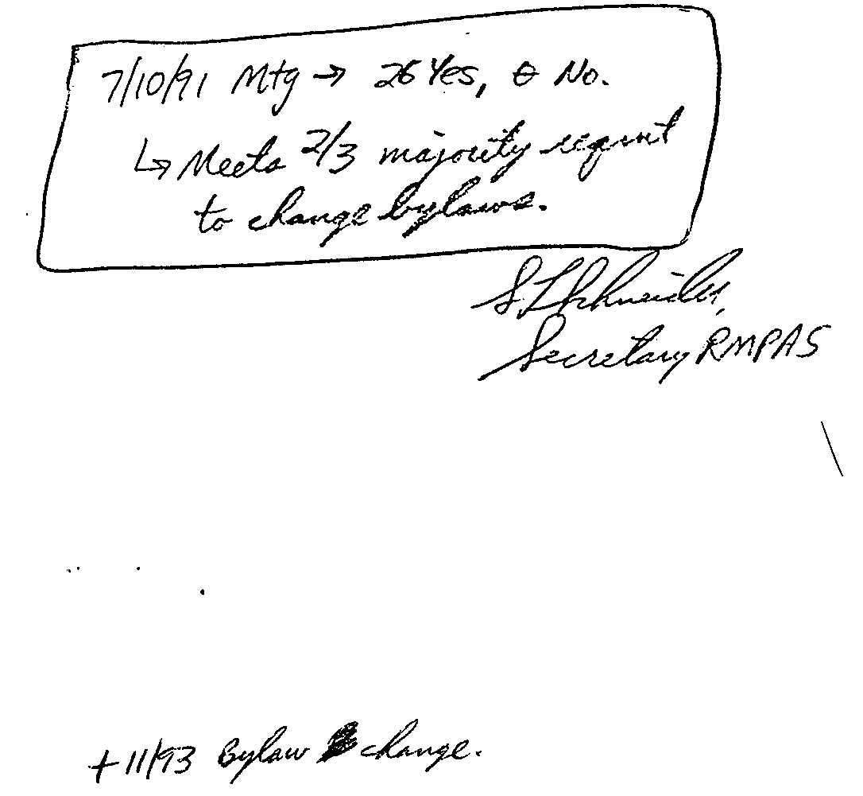

Rocky Mountain Petroleum Accountants Society

By-Laws Revision

Article IX, Section 6

November 17, 1993

Current Language

Section 5 - Audit - An annual audit of the receipts and disbursements of the Society shall be conducted. Person/persons performing the audit shall be appointed by the Board of Directors and a report will be issued to the Board of Directors reflecting the results of such audit. The audit will be for the current fiscal year and will be completed prior to December 31st for use in filing the tax return for the current year.

Proposed Language

Section 5 - Financial Records - An annual report of the receipts and disbursements shall be prepared by the treasurer within 60 days of the Society's fiscal year end. This report shall be reviewed and approved by the Board of Directors and presented to the members by the treasurer. The financial records of the Society shall be made available upon request of any member of the Board of Directors by any member desiring to review them.

APPROVAL: YES ____ NO ____

